## Illuminance data copier

1. To install on a machine, go to \\vrcapps\Installs\HeadLightDataCopier in your file browser and run the setup.exe. If it’s already on your machine you can launch from the icon.
2. You’ll be prompted to choose a target folder for the light data, or to create one if it doesn’t exist. Follow directions to name using the test date in the “illuminance data” folder.
3. During track setup, use the tabs to look at the live output as you uncover each sensor individually. Make sure only the uncovered sensor responds. (Some of the potential issues will show up as non-zero illumination for sensors which are still covered.)
4. Before testing you should also check the status of each box to make sure it has a valid GPS lock for the timestamp.
5. Prior to starting testing for the night, delete all old data from the boxes using the button on the bottom right screen from the “Light data status” tab.
6. Once the ambient illumination on all the sensors is at or below 0.2 lux, testing can begin.
7. Click the “start transfer” button to begin copying completed tests from the light boxes on the track to the network. You can pause or resume at any time, you just won’t be able to post-process until the illuminance data are transferred.

## Diadem index locations

1. For processing to work on a given machine, that machine needs to have the Headlight Data folder included in the index. To add it, open Diadem and on the Navigator tab, right click near the “Search Areas” text:  
    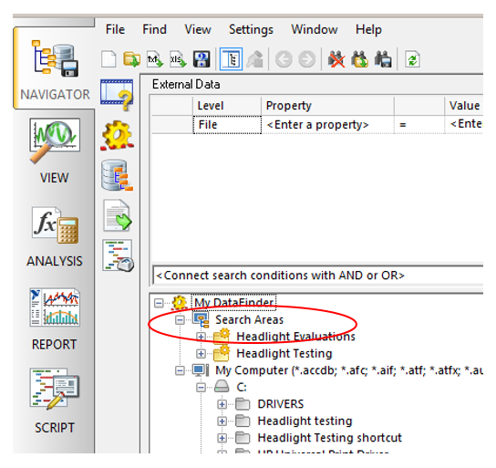
2. Choose: Configure my datafinder🡪Add Search Area🡪Path🡪 N:\VRC\Shared\Crash Avoidance Programs\Headlight Testing\Illuminance data.  
   This will not work if you use different drive letter mapping.
3. While you still have the “Configure my datafinder” window open, select the “Indexer” tab. The top two choices should look like this:

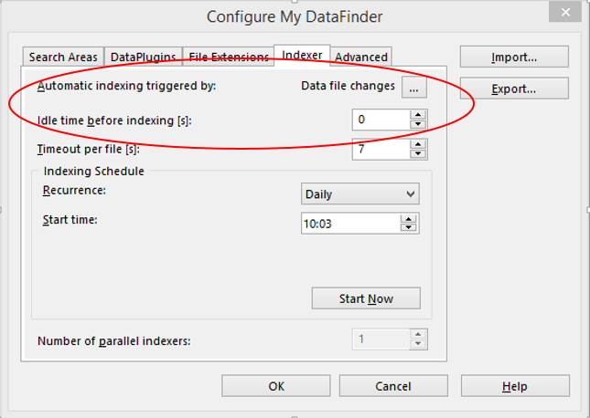

## Processing after testing is complete

1. Once completed test file has been moved to transfer directory, run the headlight script. On the main window choose "Load tdms file" then choose the appropriate file.
2. Under "Post-processing" enter the first and last test IDs that you want to process. (You can see the actual test IDs in the data portal on the right. Right-click on the test ID and choose "close groups" to collapse the list.) You don't need to include the pitch calibration runs, but it doesn't hurt anything if you do.
3. Click "Process." You can follow the progress by watching the "Processing status" at the bottom.
4. When processing is complete, you will be prompted to select a folder for saving the .tdms and .tdv files. Select the actual test folder (e.g. N:\...\Headlight Testing\HSE16001\DATA\DIAdem).
   1. If there already is a .tdms file in that directory you will be prompted about whether you want to overwrite it. If you choose not to, the processing will end without saving and then you'll need to choose where else to save. You'll also need to save the .tdv file separately.

## Processing during testing

1. When the laptop in the test vehicle is able to save files to the network you can perform real-time processing. First load the .tdms file with the test ID from the transfer folder (e.g. N:\...\ Headlight Testing\Transfer\HSE16001\HSE16001.tdms). Then save this file to the main test directory (e.g. N:\...\Headlight Testing\HSE16001\DATA\DIAdem).
2. Under “Remote monitoring and illuminance sync” the “Save location” should be updated to the main test directory chosen in step 1. For “Monitor location” select the transfer folder for the appropriate test (e.g. N:\...\ Headlight Testing\Transfer\HSE16001).
3. Choose “Monitor” and then click the play button when you’re ready to begin processing.
4. As new test files are saved, they will be displayed in the “Test results” window. Once there are 3 valid tests, the averages will be calculated and displayed in the “Total valid tests” window.
5. Click the stop button when testing is complete.

## Adding runs to partially processed file

If testing is complete and there are still runs to process, you can choose the “add runs” button (circled below) to load new runs from the completed vehicle file.

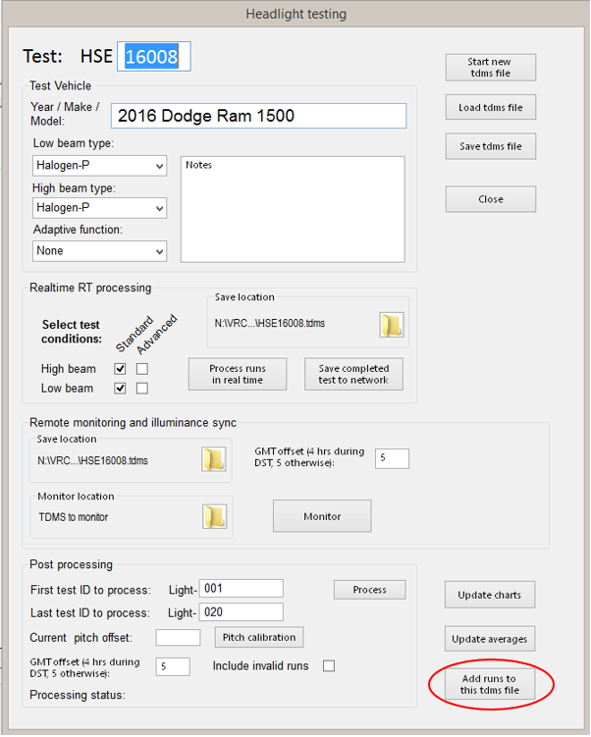

## Checking light data without any vehicle data

The "Illuminance data" folder in the headlight testing directory has the data as it is imported during testing. If you have the time, it is a good idea to load one test from each of the 5 locations to make sure that data are being saved correctly. You can plot each of the illuminance data channels against the timestamp channel.

## Data review and verification

1. Data structure: the .tdms files have the following channel groups:
   1. "Summary" contains the summary values for individual runs as well as the 3-run averages. It also has the glare exposure boundary curves and the speed corridor curves.
   2. "Track" contains the track elevation survey data and lane boundaries. The elevation is used for the pitch correction process. The lane boundaries are used to define curve start/end points as well as determine lanekeeping for test validity.
   3. "Light-???" Each of the runs (valid and invalid) is saved as a separate channel group. The group properties will tell you the headlight condition and curve type(s). There could be two curve types if the left and right were done successively in one run.
      1. Channels "Date (GPS)" - "AngleRoll (deg)" are all unchanged and taken directly from the RT.
      2. "DateTime" just combines the separate date and time channels into one.
      3. "150LFullCurveDistance" (e.g.) is the full RT "Distance (m)" channel reoriented to the endpoint of the given curve. So, for example, a distance of -100 m indicates a point 100 m after the gate on that curve. Use these distance channels as the x value if you want to compare any of the RT channels, such as RT pitch angle.
      4. "150LCurveDistance" (e.g.) is the trimmed distance for the given curve. Because it is trimmed you can't use this as the x-value for the untrimmed RT channels. These channels and everything afterward are created during processing, so if they don't exist this curve wasn't processed, possibly because it wasn't valid.
      5. "150LRGT040HI" (e.g.) is the trimmed illuminance data for a given sensor, in this case the 150L curve, right hand side of the road, 40 cm from the ground, hi sensor gain range (so lowest resolution). You can plot these channels vs. the trimmed curve distance.
      6. "150LRGTLOAdj" (e.g.) is the pitch-adjusted illuminance data for a given sensor and gain range.
      7. "150LRGTLux" (e.g.) is the pitch-adjusted illuminance data for a given sensor, combining all the gain ranges to give the highest resolution where possible.
      8. "150LRGTLuxFilt" (e.g.) same as above but using a moving average to filter (50 msec on each side of the data point).
      9. "150LGLRLuxExposure" (e.g.) contains the glare exposure data
      10. "150LGLRLuxExposureDistance" (e.g.) contains the distances that the level of glare exposure was observed. Always use this distance when plotting the channel above.
   4. "Lux-Straight" (e.g.) contains all the illuminance data for a given curve condition for all tests. As new tests are processed, these channels grow in length. After processing these groups are no longer needed, but if you have to reprocess a test it is a bit faster to still have the data loaded
2. Click "Close" on the headlight testing window, then click "View" on the left.
3. Start with the "summary” tab. The left window shows every test run with the lane and speed keeping results. The right window shows the averaged data by curve type and headlight condition. There is a column showing the total number of valid runs, but the averages are calculated using the first 3 valid runs only.
   1. Make sure there are at least 3 valid runs for each condition.
   2. Use the "min" and "max" columns to check for outliers. The range for a given measurement will generally be within 1-2 meters, but this can be greater for high beams, straightaways, and some vehicles with AFS. If there are some potential outliers, just make a note of those test IDs to check later.
   3. For the low-beam conditions, check whether the 3 valid tests had the same glare outcome (either all passing or all failing). It's possible they'll be different if it's just a borderline case, but you'll want to make sure you check that the runs which failed weren't actually high beams.
4. Now go through each of the tabs that show the unique combinations of headlight condition (high/low beam) and curve types. On each tab the top 3 windows, in order, show the left side illuminance vs distance, right side illuminance vs distance, and glare illuminance vs distance. The first 2 windows on the bottom row are just zoomed in versions of the curves above. The bottom right window shows the glare exposure curve along with our boundary for acceptable glare.
   1. Look for any drop-outs in the data and for consistency between the runs. Keep in mind that the charts will show all valid runs (not just the first 3 being used for the average). Also, if the vehicle was tested with AFS on and off, all that data will be shown together. This is the only place to verify that the AFS status was actually recorded correctly. (You can check this in the data portal on the right by looking at the group property called "Headlight condition" for a given run.)
   2. If the low/high beam status was incorrectly recorded it should be obvious from the glare measurements.
5. Look at the two "pitchangles" tabs to make sure there is are no major discrepancies that would suggest the RT strut had shifted during testing. This would normally appear as two different groups of curves, one before and one after the strut movement, which last for the duration of the run.